WIKA expands production in Saudi Arabia with a new plant

The WIKA Group, a leading global player in industrial measurement technology, is strengthening its commitment in Saudi Arabia: The company commissioned a new plant with state-of-the-art production facilities in Dammam on February 29th. With this strategic investment, WIKA is expanding its position as a local manufacturer.

The factory enables WIKA to serve customers in Saudi Arabia and in the region even more extensively. In the future, products for measuring pressure, temperature, level and flow will be manufactured there on a total area of 3,000 square metres. This includes diaphragm seals, instrumentation valves and thermometer thermowells for connecting measuring instruments to critical processes. Another focus is the implementation of IIoT solutions to support customers in the digitalisation of their processes. The range of services is also being expanded.

“WIKA’s expansion in Saudi Arabia will create more than 100 new jobs over the next few years. It, thus, makes an important contribution to the local job market. In the new plant, German top technology is implemented by a qualified team with in-depth knowledge of the local market. This ensures that customers are supplied with high-quality instrumentation solutions tailored to their specific needs,” emphasised CEO Alexander Wiegand at the inauguration ceremony.

WIKA sees itself as a partner in Saudi Arabia’s economic development, especially on the way to expanding promising economic sectors alongside oil and gas. The group of companies has been present with sales subsidiaries in the Kingdom for over 20 years.

At the inauguration, the German ambassador, Michael Kindsgrab, also recognised the WIKA Group’s investment in Dammam. It would further deepen the close relationship between Germany and Saudi Arabia. The ambassador cited the new plant as an example of the opportunities opening up for German companies in the country.

About WIKA:
With 11,200 employees, the WIKA Group is a global market leader in pressure and temperature measurement and sets the standard in the measurement of level, force and flow, and in calibration technology. The broad portfolio of high-precision products, solutions and services makes the family-run business a strong and reliable partner. WIKA’s unique experience and know-how make sensing technology smarter, add more value and prepare it for a sustainable future: That’s “Smart in sensing”.

For further information, please visit WIKA’s website or contact us: www.wika.com

Number of characters: 1.951
Code word: Saudi Arabia

Manufacturer:
WIKA Alexander Wiegand SE & Co. KG
Alexander-Wiegand-Straße 30
63911 Klingenberg/Germany
Tel. +49 9372 132-0
Fax +49 9372 132-406
vertrieb@wika.com
www.wika.com

WIKA company photograph:

Images of the opening ceremony
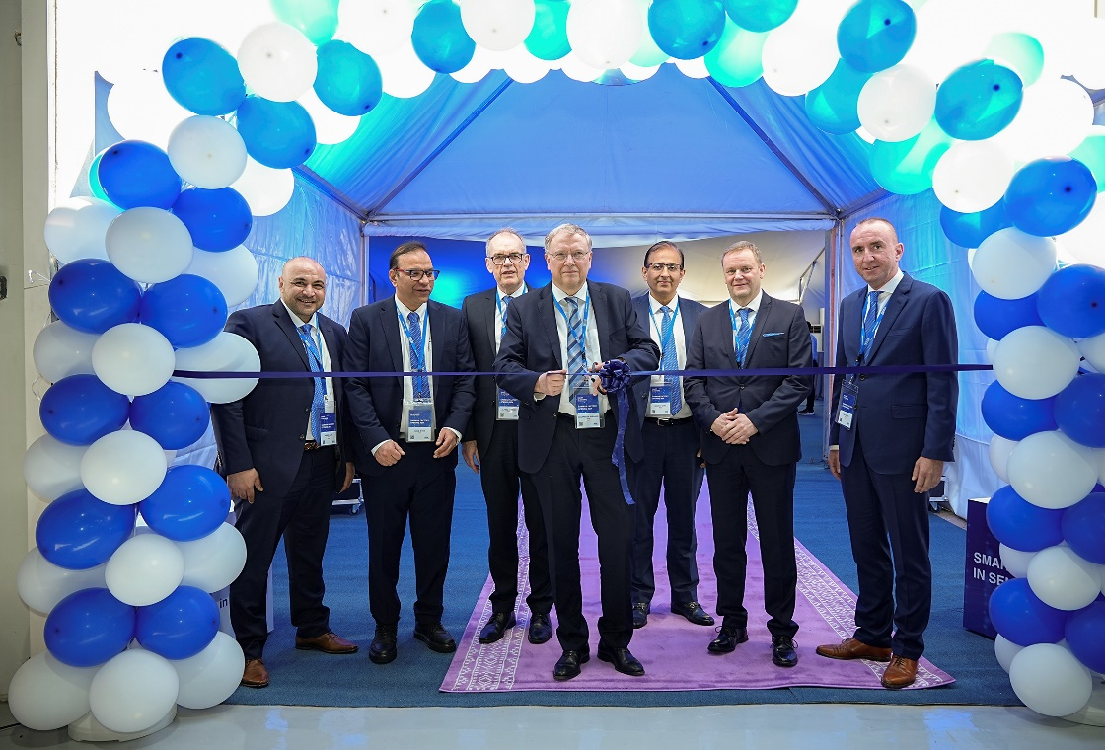

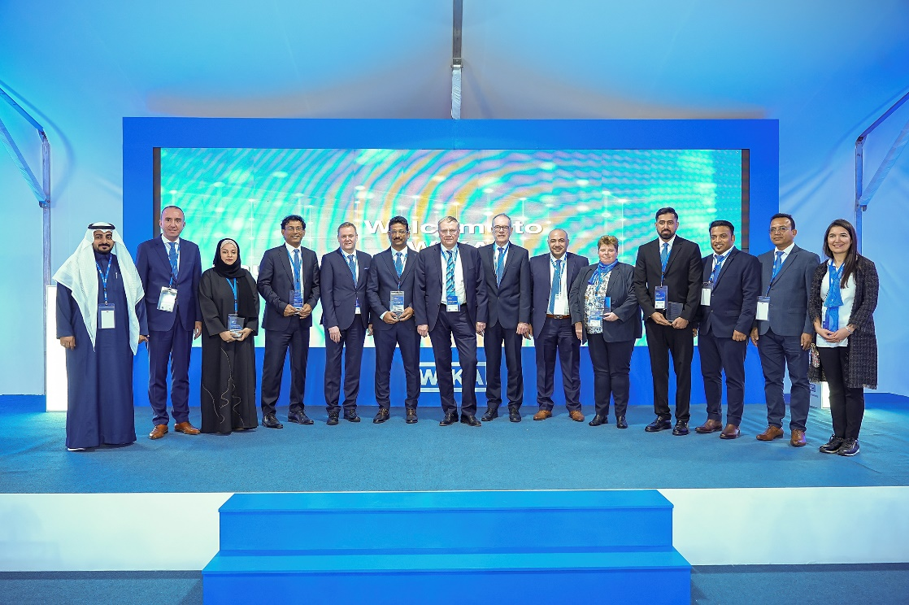

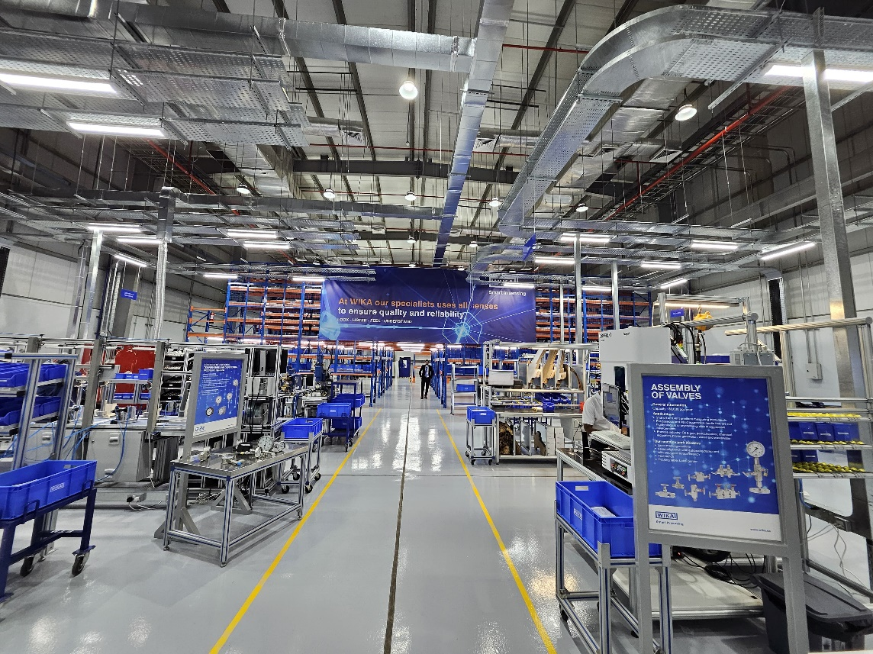
WIKA production in Saudi Arabia

Edited by:
WIKA Alexander Wiegand SE & Co. KG
Stefan von Westberg
Director Field Marketing EMEAI
63911 Klingenberg am Main
Germany
Phone +49 9372 132-4026
Mobile +49 151 744 67 667
stefan.vonwestberg@wika.com

WIKA press release

