New digital indicator:
Many functions, compact design

Klingenberg, January 2015.
WIKA has added a new instrument to its digital indicator programme: The model DI32-1 is multi-functional and, with its dimensions (48x24x52 mm), ideal for applications with limited mounting space.

The multi-function input of the DI32-1 digital indicator offers 23 input configurations. Thus, the measured values from transmitters with current and voltage signals as well as those from resistance thermometers and thermocouples can be displayed. The instrument is also suitable for frequency and rotational speed measurements, and, in addition, as an up/down counter. The indicator also records min/max values, enables the linearisation of sensor values with up to five programmable points and has a tare function. All readings are shown on a large four-digit display.

The new digital indicator features two transistor switching outputs. Their characteristics are parameterisable independently of each other.

All settings of the instrument can be made directly through the control keys on the front.

Number of characters: 1074
Key words: Digital indicator DI32-1

Manufacturer:
WIKA Alexander Wiegand SE & Co. KG
Alexander-Wiegand-Straße 30
63911 Klingenberg/Germany
Tel. +49 9372 132-0
Fax: +49 9372 132-406
vertrieb@wika.com
www.wika.com

WIKA company photograph:
Digital indicator DI32-1

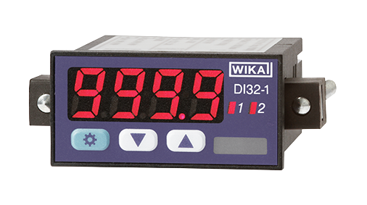

Edited by:
WIKA Alexander Wiegand SE & Co. KG
André Habel Nunes
Marketing Services
Alexander-Wiegand-Straße 30
63911 Klingenberg/Germany
Tel. +49 9372 132-8010
Fax: +49 9372 132-8008010
andre.habel-nunes@wika.com
www.wika.com

WIKA press release 02/2015

