Measurement solutions
for heating technology

Klingenberg, December 2014.
WIKA has published a new brochure on the theme of heating technology. It offers customers and other interested parties a compact overview of measurement solutions (pressure, temperature, level) for all sectors of this market segment.

The focus is on individual applications, from solar thermal systems to combined heat and power plants. Graphic illustrations indicate the points where the measurement technology is used, which the reader can match to the corresponding products at a glance. This decision aid is supported through detailed technical information in the complete presentation of the products that follows.

Furthermore the guide introduces the comprehensive service offering for the industry. This includes the provision of innovation workshops. Here, Together with the customer, individual and even unconventional product ideas are developed and later implemented.

The new brochure is available for download in digital form at www.wika.com.

Number of characters:
Key words: Heating technology brochure

Manufacturer:
WIKA Alexander Wiegand SE & Co. KG
Alexander-Wiegand-Straße
63911 Klingenberg
Tel +49 9372 132 – 0
Fax +49 9372 · 132 – 406
E-mail Vertrieb@wika.com
Internet www.wika.com

WIKA company photographs:
WIKA brochure “Heating technology”

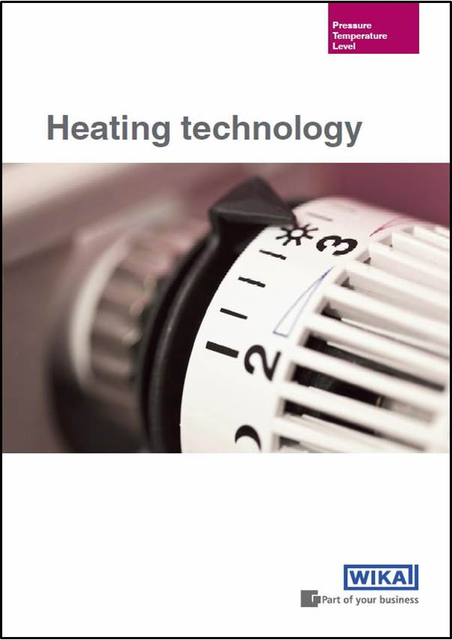

Edited by:
WIKA Alexander Wiegand SE & Co. KG
André Habel Nunes
Marketing Services
Alexander-Wiegand-Straße 30
63911 Klingenberg/Germany
Tel. (+49) 9372 132-8010
Fax (+49) 9372 132-8008010
E-mail a.habel-nunes@wika.com
www.wika.com

WIKA press release 12/2014

